Set-up ssh

- passphrase:Gr…….1…..2
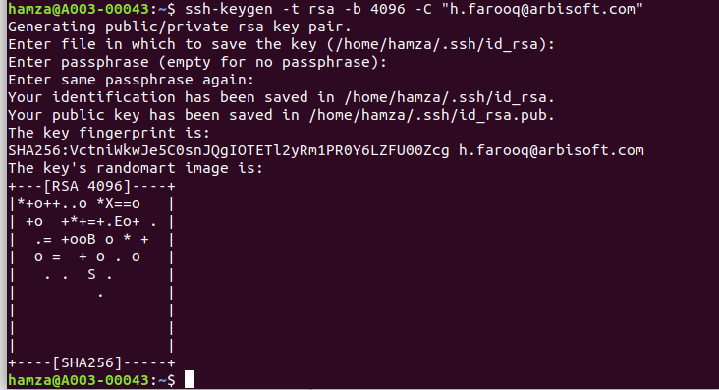
hamza@A003-00043:~$ ssh-keygen -t rsa -b 4096 -C "h.farooq@arbisoft.com"
Generating public/private rsa key pair.
Enter file in which to save the key (/home/hamza/.ssh/id_rsa):
Enter passphrase (empty for no passphrase):
Enter same passphrase again:
Your identification has been saved in /home/hamza/.ssh/id_rsa.
Your public key has been saved in /home/hamza/.ssh/id_rsa.pub.
The key fingerprint is:
SHA256:VctniWkwJe5C0snJQgIOTETl2yRm1PR0Y6LZFU00Zcg h.farooq@arbisoft.com
The key's randomart image is:
+---[RSA 4096]----+
|*+o++..o *X==o |
| +o +*+=+.Eo+ . |
| .= +ooB o * + |
| o = + o . o |
| . . S . |
| . |
| |
| |
| |
+----[SHA256]-----+

